Java SE Project

Training And Placement Application

AdminViewAllHRFrame Documentation

- AdminViewAllHrFrame -

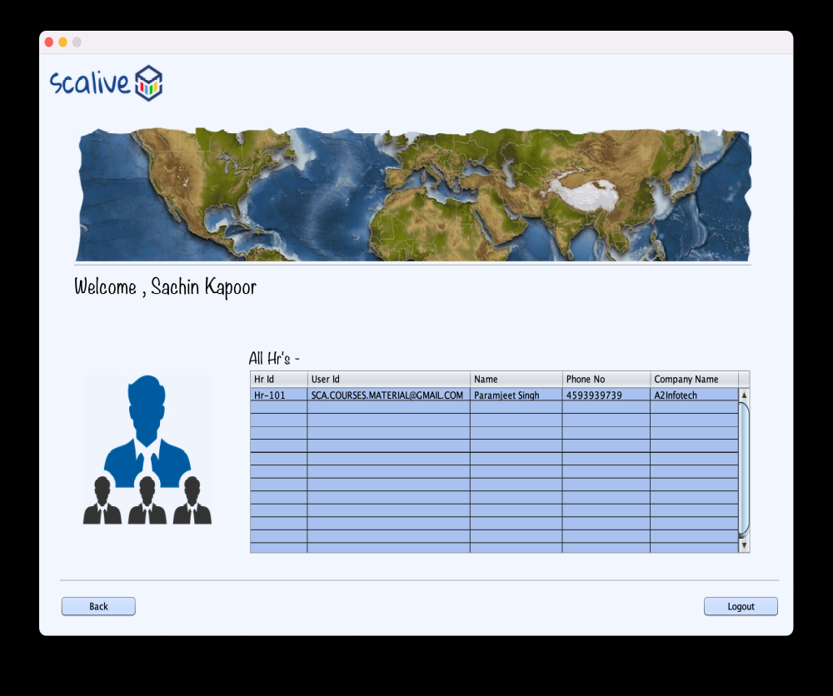

2. STEPS TO BE DONE IN AdminViewAllHrFrame

In the AdminAddNewHrFrame we need to do following steps:

- Displaying the Username
- Allow the user to logout
- Allow the user to go back
- Write code for showing all HR in JTable

- Displaying The Username
Same as before

- Allowing The User To Logout
Same as before

- Allowing The User To Go Back
Same as before

- Writing Code For Show All Hr

THE TABLES USED IN AdminViewAllHrFrame

USERS
Column Name | Data Type
USERID | Varchar2
ID | Varchar2
NAME | Varchar2
PASSWORD | Varchar2
TYPE | Varchar2

HR
Column Name | Data Type
HRID | Varchar2
PHONE | Varchar2
COMPANYNAME | Varchar2
PROFESSION | Varchar2

The HrPOJO Class

public class HrPojo {
private String hrId;
private String name;
private long phone;
private String companyName;
private String profession;
private String userId;
private String password;
private String type;

public String getCompanyName() {
return companyName;
}

public void setCompanyName(String companyName) {
this.companyName = companyName;
}

public HrPojo() {
}

public String getHrId() {
return hrId;
}

public void setHrId(String hrId) {
this.hrId = hrId;
}

public String getName() {
return name;
}

public void setName(String name) {
this.name = name;
}

public long getPhone() {
return phone;
}

public void setPhone(long phone) {
this.phone = phone;
}

public String getProfession() {
return profession;
}

public void setProfession(String profession) {
this.profession = profession;
}

public String getUserId() {
return userId;
}

public void setUserId(String userId) {
this.userId = userId;
}

public String getPassword() {
return password;
}

public void setPassword(String password) {
this.password = password;
}

public String getType() {
return type;
}

public void setType(String type) {
this.type = type;
}

}
WRITING THE CODE FOR BUTTON IN AdminAddNewHrFrame

Returning All Hr List

To return a list of all HR we must define a method in HrDAO called getAllHr().

This method should return HRID,USERID,HRNAME,COMPANYNAME and PHONE of all HR from the DB

So the prototype of the method is:

public static List<HrPojo> getAllHr()throws SQLException

The Code For getAllHr()

public static List <HrPojo> getAllHr()throws SQLException{
Connection conn=DBConnection.getConnection();
Statement st=conn.createStatement();
ResultSet rs=st.executeQuery("Select hr.hrid,users.userid,users.name,hr.phone,hr.companyname from hr,users where hr.hrid=users.id order by hr.hrid");
List<HrPojo> allHrList=new ArrayList<>();
while(rs.next()){
HrPojo obj=new HrPojo();
obj.setHrId(rs.getString(1));
obj.setUserId(rs.getString(2));
obj.setHrName(rs.getString(3));
obj.setPhone(rs.getString(4));
obj.setCompanyName(rs.getString(5));
allHrList.add(obj);
}
return allHrList;

}

The Code For Frame

private DefaultTableModel model;
public AdminViewAllHrFrame() {
initComponents();
model=(DefaultTableModel)tblAllHr.getModel();
this.setLocationRelativeTo(null);
lblName.setText(CurrentUser.getName());
loadHrDetails();
}

private void loadHrDetails() {
try{
List<HrPojo> allHrList=HrDAO.getAllHr();
for(HrPojo hr:allHrList){
Vector <String> row=new Vector<>();
row.add(hr.getHrId());
row.add(hr.getUserId());
row.add(hr.getHrName());
row.add(hr.getPhone());
row.add(hr.getCompanyName());
model.addRow(row);
}
if(allHrList.isEmpty()){
JOptionPane.showMessageDialog(null,"No Hr Present!","Hr Not Present!",JOptionPane.INFORMATION_MESSAGE);
}
}
catch(SQLException ex){
JOptionPane.showMessageDialog(null,"DB Error","Error",JOptionPane.ERROR_MESSAGE);
ex.printStackTrace();
}
}
}

